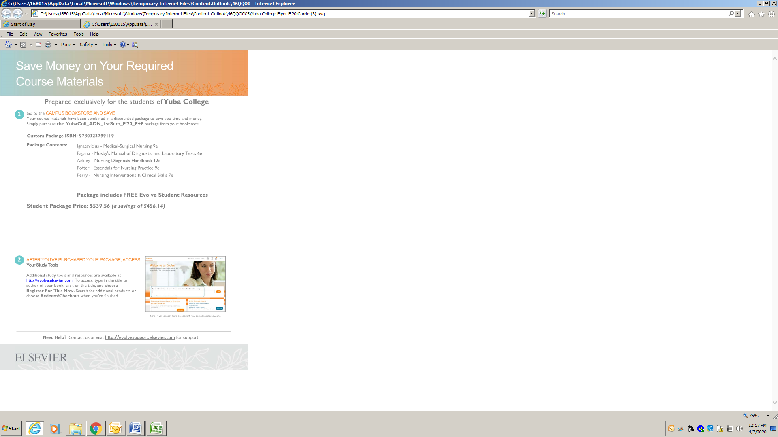

*\*Most components available separately in Bookstore*