Yuba College Nursing
HealthStream Hospital Orientation Modules

URL to access: www.healthstream.com/hlc/canursing

HealthStream Customer Service (available 7a-7p CST, M-F): 1-800-521-0574

Available courses:
- HIPAA (1 hour)
- Rapid Regulatory Compliance Clinical I (40 minutes)
- Rapid Regulatory Compliance Clinical II (55 minutes)
- Hazard Communication (1 hour and 15 minutes)

Directions for completing Hospital Orientation Modules
- Go to www.healthstream.com/hlc/canursing
- Click on “First time students click here to register” (screenshot below)

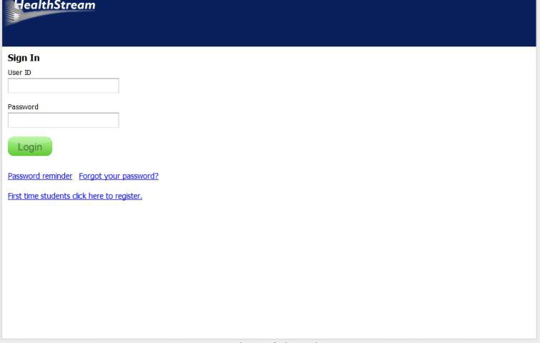

- Select “Yuba College” from the dropdown menu:

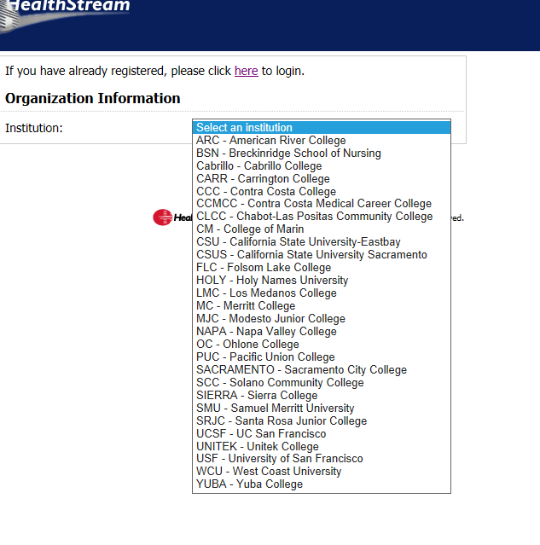
5) Enter your general information – first and last name, create a username and password, etc. You must fill out all boxes with an orange asterisk. *
IMPORTANT Your password will be uniquely yours and no one else will have access to it. Call Customer Service with any issues with passwords or student accounts. **
- The “hire/rehire” date and the “active date” should be the same date that you sign up.
- You can leave the “Review Month/Day” field blank.
- For “Department” please select “001 – Other”
- Click submit.
- In the next window, click on the “catalog” tab

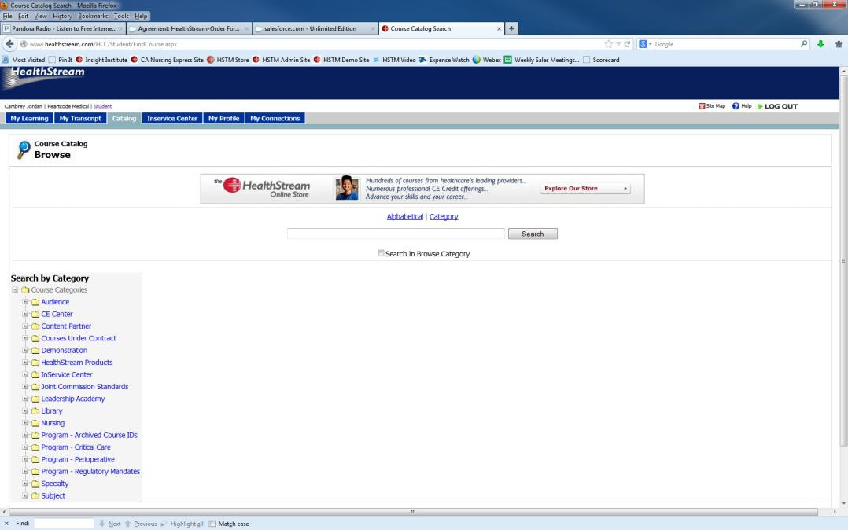

- In the search box, type in HIPAA and then click “search”.
- The course title will appear and then you should click on it.
- Once you have selected the course, you’ll see all of the course details and you should click “Enroll in this course” – this will be towards the right hand of the screen. The fee for each of the four courses you must take is $3.50.
- Enter credit card information and then “continue.”
- You will now have access to begin the course.
- You will need to use Microsoft Internet Explorer 8.0 and higher.
- You will also need Adobe Acrobat Reader 6.0 or above, and Adobe Flash Player 7.5.1 or above.
- You may log out and log back in as needed. Once you have completed a course, print out the completion certificate and keep this on you while in clinical.
- **Call HealthStream Customer Service at 800.521.0574 if issues arise. They are only open 5 am to 5 pm Pacific Standard Time (7a-7p Central Time) from Monday through Friday. It is highly recommended you establish your account during this time so you can get help right away if you have problems. Once you establish your account, you may return to it 24/7 to complete the modules.

