Proctored Exam Example of Remediation
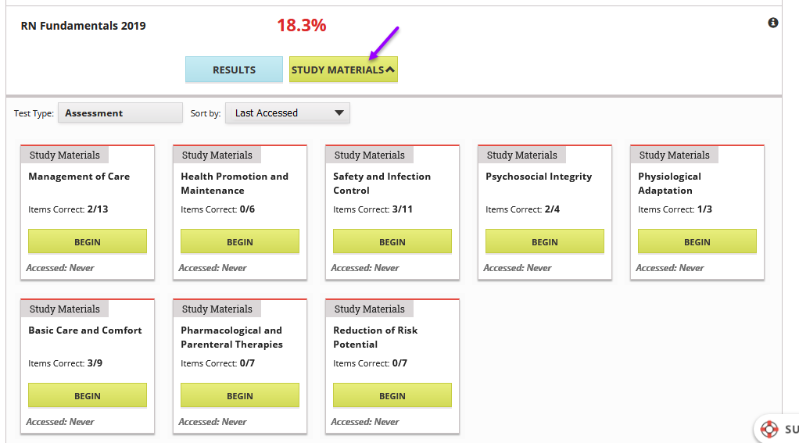
Practice Exam Example of Remediation – Notice there is a video also available
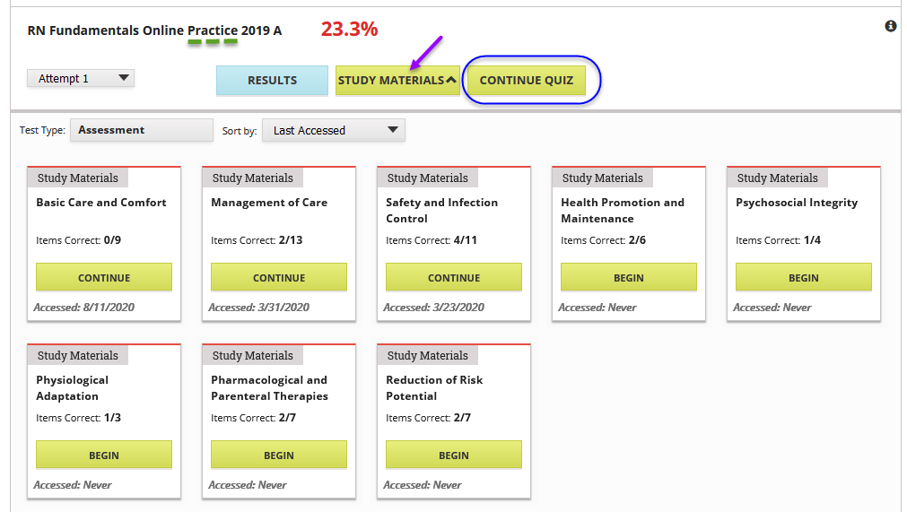
Continue on next page

