1st Semester Nursing Textbooks
Purchase Materials and view all pricing options @ www.yubashop.com

Bundle:
Author | Title | ISBN/EAN | Copyright | New
Elsevier | Nursing 1 ADN Bundle (Spring 21)(CUSTOM) | 9780323887663 | 2021 | $591.06

Individual components available through Yuba College Bookstore:
Author | Title | ISBN/EAN | Edition | New
Pagana | Mosby's Manual of Diagnostic & Lab Tests | 9780323446631 | 6th | $72.95
Potter | Essen for Nursing Practice | 9780323481847 | 9th | $127.00
Perry | Nursing Interventions & Clinical Skills | 9780323547017 | 7th | $114.75
Ackley | Nursing Diagnosis Handbook | 9780323551120 | 12th | $69.95
Ignatavicius | Medical-Surgical Nursing | 9780323612425 | 10th | $221.00

**Rental, Used, and Digital options offered on most titles
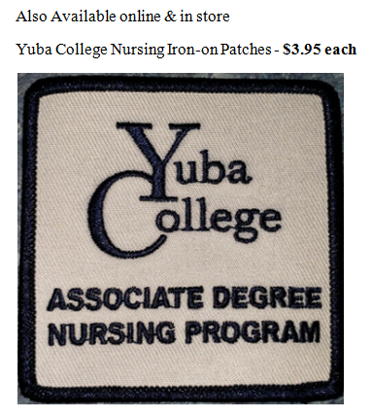

Ways to reach us:
Yuba College Bookstore
Tel: 530.741.6998
2088 N. Beale Rd Bldg 300, Marysville Ca 95901
0640mgr@follett.com
Open: Monday- Thursday 8am – 3pm, Friday 8am – 12pm

