Access codes can be purchased in two diﬀerent ways:
- Custom Package Access Codes, provided in a package you purchase at your bookstore
- Individual Product Access Codes, typically purchased by the student or provided by faculty

*** ATTENTION – MUST READ FIRST ***

Redeeming Your Access Code(s)
Whether you access your online materials via your institution’s learning management system (LMS) or via your Evolve account, you must complete the following steps to redeem your access code(s) ﬁrst.
- You must ﬁrst go to the Evolve site at https://evolve.elsevier.com/student.
- Scroll down until you see Redeem an Access Code or Enter an Evolve Course ID. Enter your ﬁrst access code (if you have multiples) exactly as listed on the card you received/purchased and click Submit. 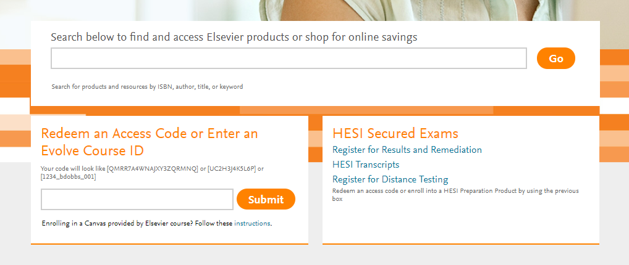
- You will see a screen that shows what Evolve products and resources your code will redeem. Click Redeem. You are now prompted to log into your existing Evolve account or to create a new account. (ONLY ﬁrst-time users should create a new account.)
  - If creating your account for the ﬁrst time, you must enter in your institution’s email address instead of a personal address.
  - If you previously had an Evolve account:
    - If you are a returning Evolve user, after signing in, it may prompt you to Update your Account details. Make sure the Email address ﬁeld is your institution email, not a personal email.
    - Forgotten your login details? DO NOT CREATE A NEW ACCOUNT. Click Forgot Username or Password? and follow the prompts to receive an email to reset your information.
    - If you are a returning Evolve user and you didn’t receive a prompt to Update your Account details then after signing in, click Account at the top-right. Go to Account Settings and update the Email Address and Conﬁrm Email Address ﬁelds with your institution email.
  - Click Continue when ﬁnished.

NOTE: If you are experiencing any diﬃculties and have any questions regarding login details, please call +1 800 222 9570 and let the customer support representative know what issues you are experiencing.

- If your access code includes an eBook, ﬁrst-time eBook users are also prompted to create a VitalSource/Elsevier eBook Library account:
  - Follow the prompts to set up your eBook library account. This will be a diﬀerent login than your Evolve account. When you are ﬁnished entering the details, your VitalSource/Elsevier eBook library username and password are sent to you via email.
- You now see a conﬁrmation page that your code is redeemed. You have now completed redeeming your access code.
  - You may have additional access codes to redeem in the back of books. If eBook includes access code it will give you option for “Reveal Access Code” or the ﬁrst page of eBook. These access codes would unlock your online course(s), additional book resources, or the eBook. Redeem any additional access codes via the “Catalog” home page under option for “Redeem an Access Code or Enter an Evolve Course ID”. Enter code and follow prompts until you reach “Confirmation” screen and click “Redeem”.
- You have now completed the steps to redeem all access codes.
  - If you are accessing these materials/online courses via your institution’s learning management system (LMS), you have completed the steps to gain access to your materials. Go to your school’s LMS site to begin working with these materials.
  - Your instructor may have online course IDs into which you need to self-enroll. You can follow the document entitled [Course ID Student Self-Enrollment] to complete these required steps, or your instructor may give you speciﬁc directions for self-enrolling.
- For any questions or additional assistance relating to anything oﬀered on the Evolve/Elsevier website, please contact Evolve Customer Support. You can click the Help tab at the top-right of the Evolve website and scroll to the bottom for direct email, chat, or phone options, or you can click the direct links below:

Email: https://service.elsevier.com/app/contact/supporthub/evolve/
Chat: https://service.elsevier.com/app/contact/supporthub/evolve/
Phone: +1 800 222 9570 (Monday-Sunday, 6:00 am-12:00 am CST).

Common Training Materials

Elsevier eBooks
Click on the My Evolve tab in your Evolve account. You will see a resource listed for Elsevier eBook Library on VitalSource (the eBook software provider). This is where you go to access the eBook online library.

You can download your eBook library so that you can access it without Internet access. See Elsevier eBook Downloadable in the below link for instructions.

To learn more about all the features of eBooks, please refer to the following eBook Training Tutorial:
http://downloads.vitalbook.com/tutorials/publish/index.html?did=elsevier#video/elsevier_downloadable_app_inside_book_hilites_notes
Within the training video go to section for “Elsevier eBook Mobile” select “Installing the Elsevier eBook App” that includes directions on how to download the app for this.

Additional Help for All Evolve Products
For additional student support and training materials please go to the Catalog home page of the Evolve site at https://evolve.elsevier.com/student and click on Elsevier Student Life at the bottom-left of the page. You can also access it directly at https://evolve.elsevier.com/studentlife/index.html.
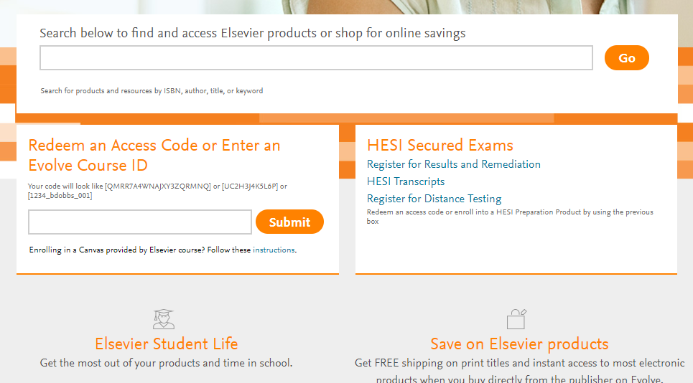
While on the Elsevier Student Life, go to the top of the page and select which Evolve/Elsevier products you would to have more information and then scroll down to see what is available:
