Yuba College Nursing
HealthStream Hospital Orientation Modules

URL to access: www.healthstream.com/hlc/canursing

HealthStream Customer Service (available 7a-7p CST, M-F): 1-800-521-0574

Available courses:
- HIPAA (1 hour)
- Rapid Regulatory Compliance Clinical I (40 minutes)
- Rapid Regulatory Compliance Clinical II (55 minutes)
- Hazard Communication (1 hour and 15 minutes)

Directions for completing Hospital Orientation Modules
- Go to www.healthstream.com/hlc/canursing
- Click on “create new account”

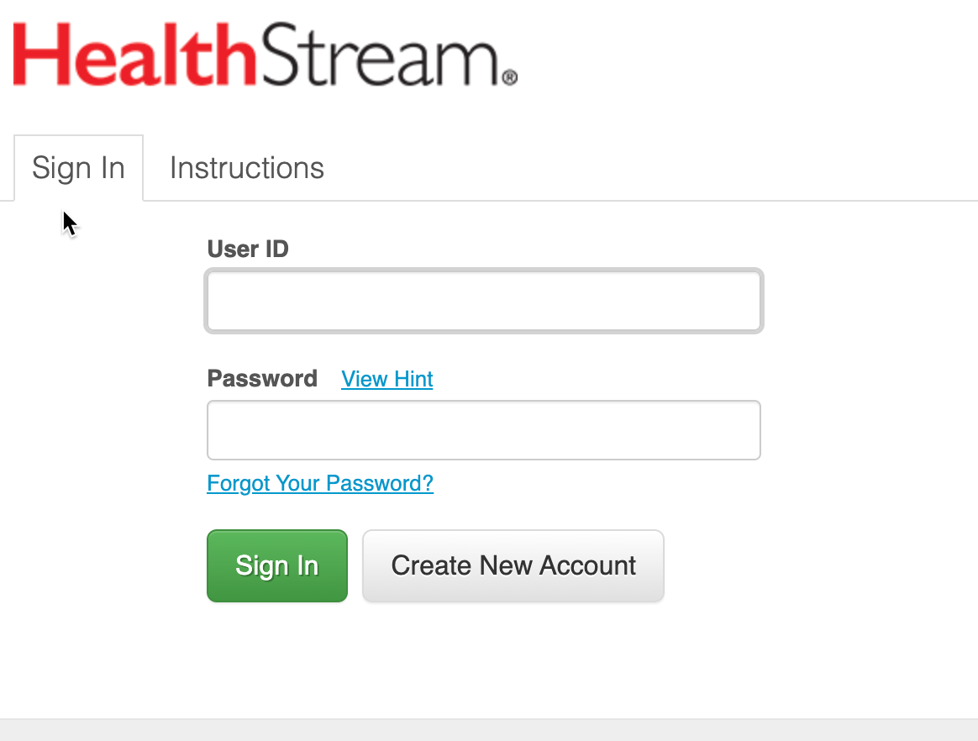
- Select “Yuba College” from the dropdown menu:

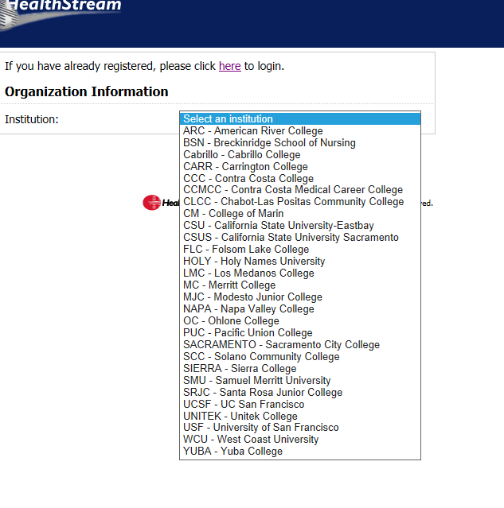

5) Enter your general information – first and last name, create a username and password, etc. You must fill out all boxes with an orange asterisk. *
IMPORTANT Your password will be uniquely yours and no one else will have access to it. Call Customer Service with any issues with passwords or student accounts. **
- The “hire/rehire” date and the “active date” should be the same date that you sign up.
- You can leave the “Review Month/Day” field blank.
- For “Department” please select “001 – Other”
- Click submit.
- In the next window, click on the “catalog” tab

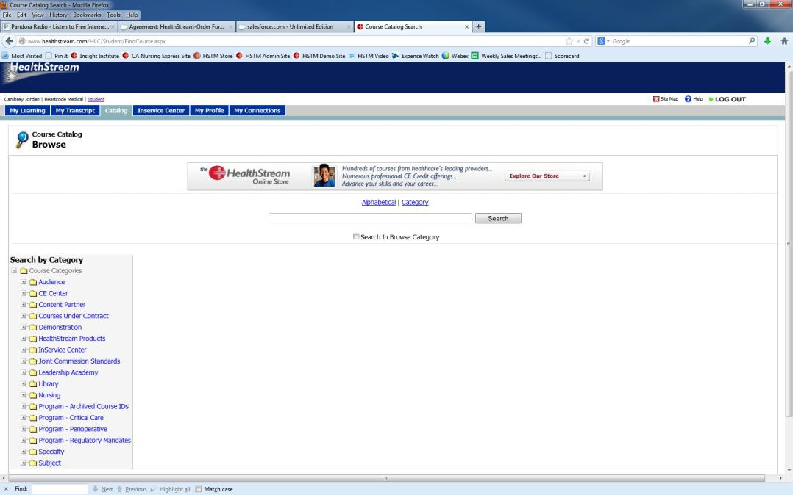

- In the search box, copy and paste the entire name of each course and hit search
  - 4 courses to complete
    - HIPAA
    - Rapid Regulatory Compliance Clinical I
    - Rapid Regulatory Compliance Clinical II
    - Hazard Communication
- The course title will appear and then you should click on it.
- Once you have selected the course, you’ll see all of the course details and you should click “Enroll in this course” – this will be towards the right hand of the screen. The fee for each of the four courses you must take is usually $3.50.
- Enter credit card information and then “continue.”
- You will now have access to begin the course.
- You will need to use: Apple Safari 8+ (Mac) Google Chrome, current version (PC/Mac) Mozilla Firefox, current version (PC/Mac) Microsoft Edge, current version (PC) Microsoft Internet Explorer 11+
- You will need to review Healthstream Technical Specifications documents for further technical requirements
- You may log out and log back in as needed. Once you have completed a course, print out the completion certificate and keep this on you while in clinical.
- You must also download your certificates as PDFs. These will be submitted per your instructors' directive.
- **Call HealthStream Customer Service at 800.521.0574 if issues arise. They are only open 5 am to 5 pm Pacific Standard Time (7a-7p Central Time) from Monday through Friday. It is highly recommended you establish your account during this time so you can get help right away if you have problems. Once you establish your account, you may return to it 24/7 to complete the modules.

