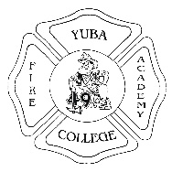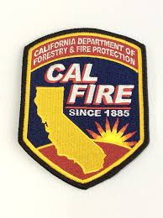

Requirements and Expectations
The goal of CTE Basic Wildland Firefighter Academy is to prepare students to become competent, confident, and skilled in the fire protection profession. In addition, you will receive training on how to prepare a resume and fill out job applications.
Listed below are requirements and expectation for class participation. Please read and check off the following information:
Student Must:
Be free of infectious disease
Maintain hands and arms free of disease (No acrylic nails)
Meet and pass the medical requirements of the Physical Evaluation form, to be completed and signed by a physician.
In addition, students must agree to the following:
_____ Interact in a positive and professional manner with instructors, fellow students, and training staff
_____ Comply with classroom/training site attire/appearance requirements
_____ Attend class, on time, as scheduled by the instructor
_____ Behave and perform in a professional manner
Your signature below acknowledges that you are verifying the information to be true and correct and that you understand and accept the class requirements.

______________________________________ _________________________________
Student Signature Date

