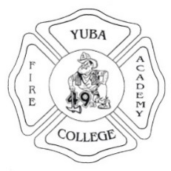
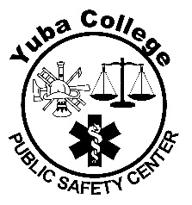
Yuba College Fire Technology
Instructor’s Verification

For Students Currently Enrolled in Fire Protection Organization

This is to verify that ______________________________________ is currently enrolled in a pre-requisite Fire Technology course entitled Fire Protection Organization at California Community College. He/She is performing satisfactorily, and I anticipate the student will earn a final grade of “C” or above.
Course Completion Date: ________________________________________________________

Instructor’s Name (Please Print): ___________________________________________________

Instructor’s Signature: ___________________________________________________________

College / Institute: __________________________Contact Number: ____________________

Date: _____________________

Notes: _______________________________________________________________________

