COURSE ANNOUNCEMENT:

**Basic Wildland Firefighter Academy**

**Yuba College — Spring 2025**

**Course Description**

**Instructors**

**Capt. Norm Alexander Div. Chief Chris Baker**

**Capt. (ret) Mike Crandall BC. (ret) Robert Stoddard**

This course provides the skills and knowledge needed for the entry- level fire fighter to recognize hazards and unsafe situations; don, doff, and maintain wildland personal protective equipment; deploy a fire shelter; maintain suppression hand tools and equipment; as- semble and prepare for response; construct and secure a Fireline;

reduce the threat of fire exposure to improved properties; and mop up and patrol a fire area when working with wildland fires.

**Class Schedule**

Jan 10— Feb 9

Fridays 1700-2100

Saturdays 0800-1700

Sundays 0800-1700

**Certificates of Completion**

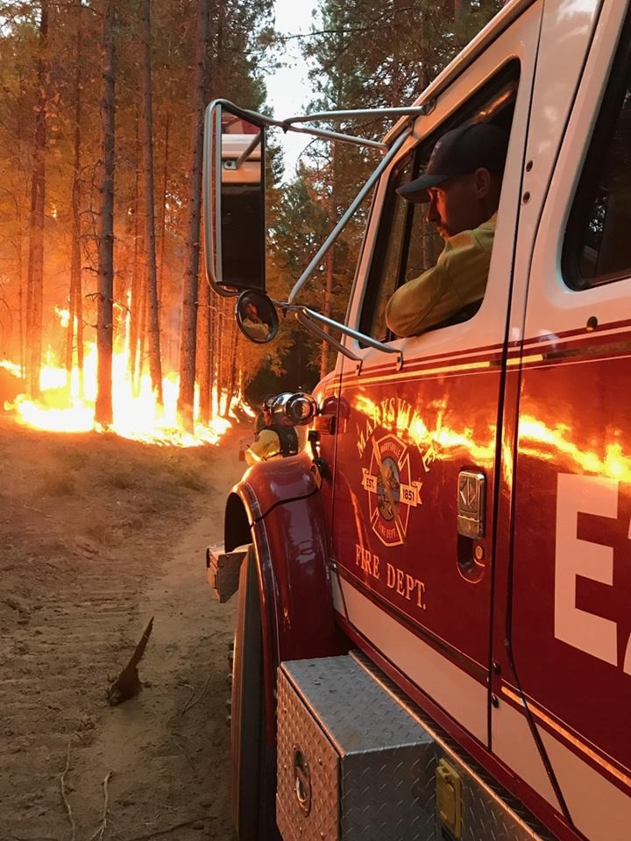

PSFA (Title 22 First Aid/CPR) Cal Fire FF 1C

NWCG S-190, L-180, S-130, S131

**Applications**

The application process will open September 23, 2024 and will close when the student cap of 30 is hit.

We must have a minimum 20 students for class to go.

**Cost**

Tuition and Admission Fees $127.00

This does not include fees for student PPE. Once you have been accepted you will be given a more detailed list of what PPE is needed.

https://yc.yccd.edu/publicsafety/home-page/fire-technology