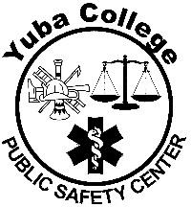
YUBA COLLEGE PUBLIC SAFETY

SPECIAL INVESTIGATORS’ BASIC COURSE STATEMENT OF APPLICANT

It is my intention to enroll in the Yuba College Special Investigator’s Basic Course (AJ 55). I have read and understand the following:

- I must attend the Mandatory Orientation meeting scheduled at Yuba College, 2088 North Beale Road, Bldg. 2100, Room 2150, on:
  - Sunday, August 2, 2026, at 8:00 am. More information will be provided in your orientation letter

- I may not be eligible to participate if I am on academic or progress probation, pending review and determination by Yuba College.

- I understand that the course will be a physically and academically challenging course. It will be a time-consuming commitment and may place extraordinary demands on my time and resources.

- The academic standard is rigorous, requiring 80% or greater on all quizzes and examinations.

- The motor skills test standard will be according to the standards established by the Peace Officer Standards of Training (POST).

- My attendance is required at all sessions, unless excused by the Police Academy Coordinator. I understand that some classes are mandatory, and if I miss any of them, there is no make-up. This would prevent me from successfully completing the course.

- Punctuality, attitude and participation are components of the course grade. Problems in any of these areas could result in administrative dismissal from enrollment.

- I am responsible for obtaining uniforms, equipment, and other supplies according to course requirements and specifications.

PRINT NAME:
SIGNATURE: DATE:

