YUBA COLLEGE
VETERINARY TECHNOLOGY PROGRAM APPLICATION
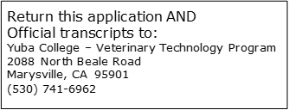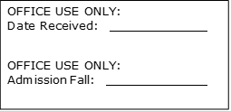

Legal Name: (Do not use nicknames)

(Last Name) (First Name) (Middle)

Other Names Used: (Maiden, Other)

Mailing Address:

Primary Phone Number: Secondary Phone Number:

(Area Code) Number (Area Code) Number

E-mail Address:

College ID Number:_________________ Birthdate:______________

Gender: Male Female Non-Binary Other/Opt Not to Disclose

Ethnic Background: Circle One

Asian Indian | Vietnamese | African American | Other Pacific Islander
Cambodian | Other Asian | American Indian | White, Non-Hispanic
Chinese Korean | Central American South American | Filipino Guamanian | Other Non-White
Laotian Japanese | Mexican, Mexican/American Other Hispanic | Hawaiian Samoan
How did you hear about the Program? ______________________________
Name of high school: ______________________________ Year graduated:______

High School GPA (If graduated in the last 3 years): ___________

Name of colleges attended:

Cumulative College GPA: ____________________________

Official college transcripts attached

The prerequisite courses MUST be completed with a minimum average GPA of 2.5 prior to acceptance into the Program.

Life Science: BIOL 1, BIOL 4, BIOL 10L, BIOL 15, or BIOL 24L  Chemistry: CHEM 10, CHEM 1A, or CHEM 2A  Veterinary Assisting: VETT 91 |  | GRADE  RECEIVED | WHERE TAKEN | WHEN TAKEN
Note: If course is in progress please indicate IP.
PROGRAM PREREQUISITES | Biology
 | Chemistry
 | Vet 91
It is not required that the classes listed below be completed prior to acceptance into the Veterinary Technology Program however they are required for graduation.
GENERAL EDUCATION | Please see a counselor to verify you have met these requirements.
 | English 1A
 | Intermediate Algebra
 | Social Science
 | Humanities

With this Application and transcripts please submit a type-written narrative answering the following:

Describe your academic goals and why you have chosen the Yuba College Veterinary Technology Program. Include in your essay why you feel you are a good candidate for this Program and what you plan to do in a future career as a Registered Veterinary Technician.

Signature: _______________________________ Date: ______________

