Transcript Video 1: Overview
Greg Kemble here.
I’m Yuba College’s Academic Senate president, a Guided Pathways Lead, and a part of the
Guided Pathways Workgroup at the College.
One of the things we’ve heard from a number of people is that, while there are quite a few of us who have been exploring Guided Pathways for awhile, there are also quite a few of us who have not been, and who still have some basic questions, like, What is this guided pathways thing? And why are we even talking about it?
So we decided to put together a short series of short videos to try to address these questions.
In this video, I’ll give a brief overview of what the guided pathways framework is, and why we should be interested. In future videos, numbers two through five, we’ll look at each of the four pillars of
the guided pathways framework. And then, in the sixth and last video, I’ll talk a little bit about opportunities, challenges, and concerns that swirl around the Guided Pathways framework.
So: what are guided pathways?
In some ways, that’s a trick question. For one thing, we already have a bunch of things that qualify as guided pathways. The checklist of things students needs to do to apply to the college? That’s a guided pathway. A list of courses that lead to an automotive degree? That is a guided pathway. The associates degree for transfer, which offer fairly clear paths for students to transfer to CSU with Junior status? That’s a pathway.
But we’re talking about something bigger here. When we talk about guided pathways, we’re not just talking about these individual pathways. We’re talking about a framework – the Guided Pathways Framework.
And by framework we mean a way of organizing the institution – the whole college – around students’ experiences, building on what we’re already doing well, and improving things that we just aren’t doing so well – and doing it “at scale.” That’s a phrase that comes up often. At scale – that means for all students, not just students who happen to fit in various silos.
So it’s not just about creating lists of classes that lead to a goal, though creating clear road maps is part of the process. It’s about starting conversations with students right away about their career goals, and how our college will fit that. For those who aren’t sure what their goals are, it’s about designing ways for them to explore possibilities without having to start over when they finally do make a decision. It’s about supporting students – from the moment they show interest in us, to the moment they leave us.
So: why are we thinking about this?
Well, there are a number of reasons. The least interesting is that this is the direction the state is moving, and that means that there will be carrots and sticks tied to this.
One of the carrots – and this is already in play – is funding. One of the sticks is that colleges that don’t sign on to the guided pathways framework cannot participate, for example, in the California Promise program, which is a program in which first-time, full-time students get free tuition for the first year.
The state chancellor is pushing it. The legislature is pushing it – AB 705 which, among other things, pushes for acceleration in English and math – this is all aligned with guided pathways. It’s the direction the state is moving.
A more interesting reason, at least to me, is that our students’ outcomes are not meeting their stated goals. Here is a graphic: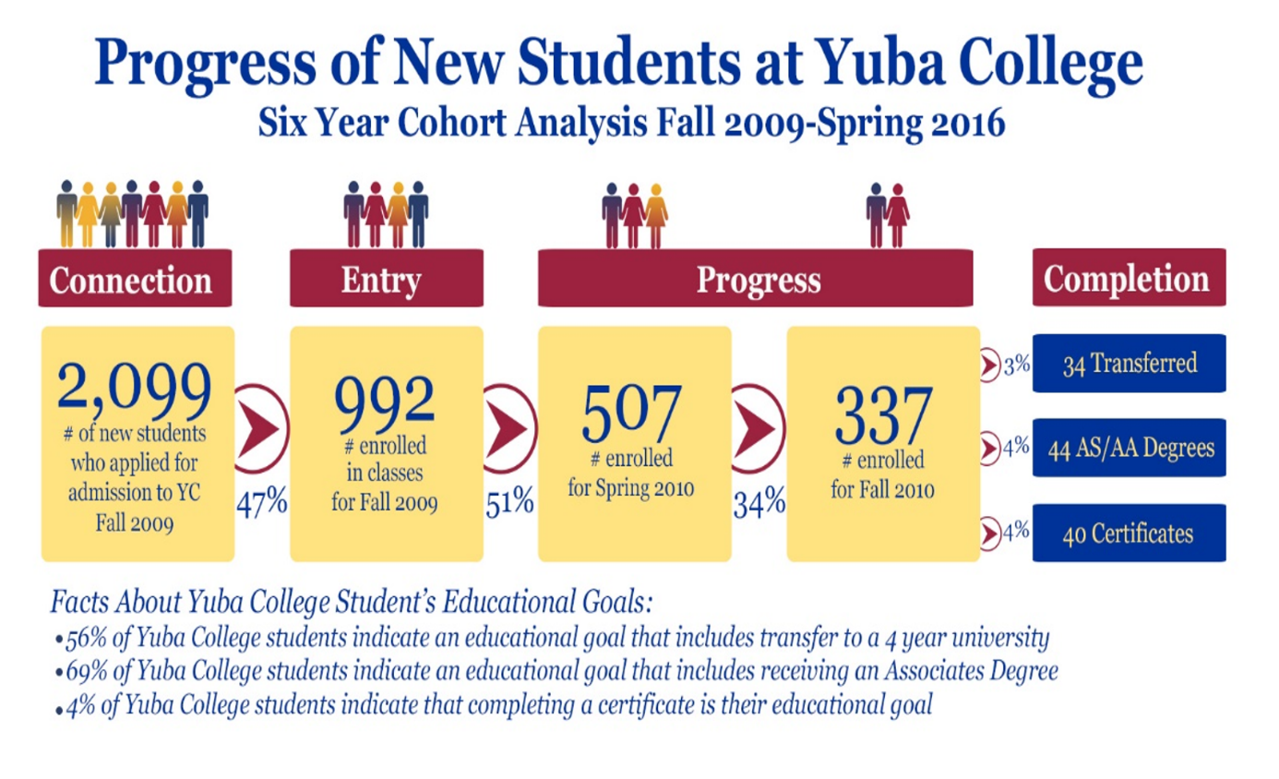
You may have seen this floating around the campus, and there are a lot of parts to it. But I want to focus on one aspect:
The majority of our students say they want to transfer (56% said that) or they want an Associates degree (69% said that). Yet of the almost 1000 students who enrolled in classes in fall 2009, only 7% of our students had met that goal within six years.
7%.
Now, we can raise all kinds of objections to the data. Do we know how many got their degree within 7 years, or 10? How many of the students are just checking the box on the application? When they apply, do they even know what they’re saying when they say they want to transfer, or to have an Associates degree?
But in the end – for me, at least – the question has to be: am I satisfied that 7% of the students who enrolled in 2009 transferred or had a degree within six years? Is that evidence that we are fulfilling our commitments to our students?
Now, that does not naturally lead to guided pathways. But another reason for embracing them is the success that they have had across the nation.
Here’s a chart from Georgia State University, who have been working with guided pathways for a decade or so.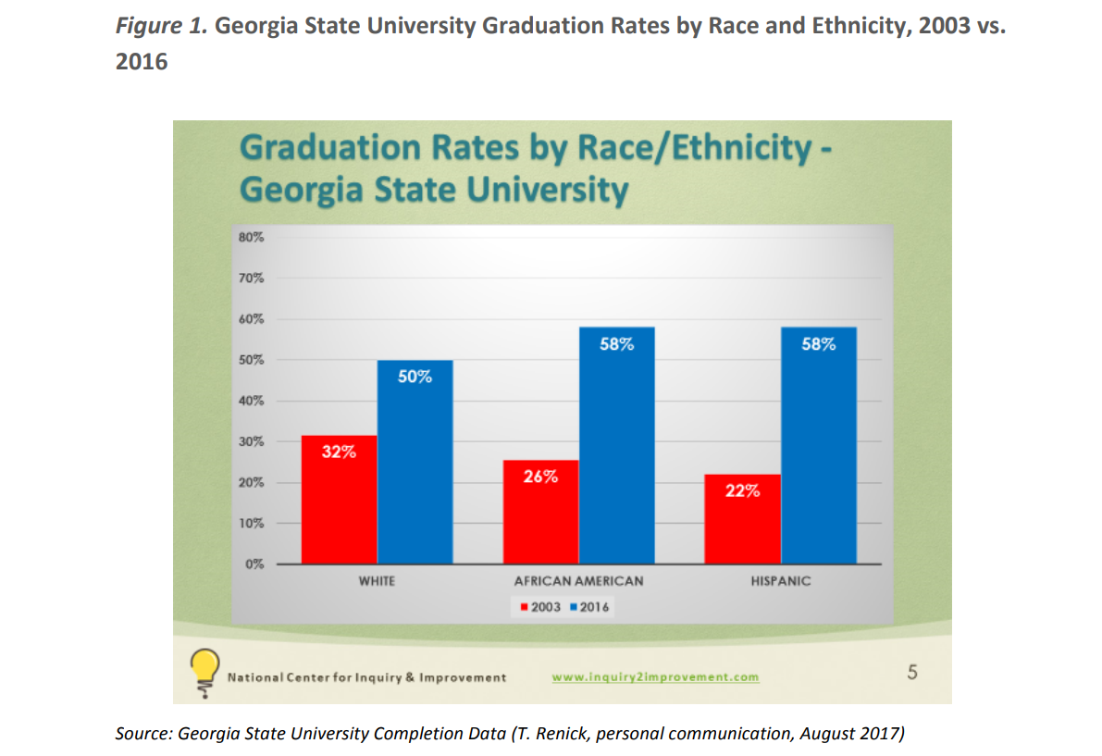
There are two things that are notable here:
First, of graduation rate for all three groups improved significantly.
But second – and for those of us who are interested in student equity, this is really significant – the achievement gap flipped. So, in 2003, whites graduated at a higher rate than both African-Americans and Hispanics; in 2016, African-Americans and Hispanics graduated at a higher rate than whites. All groups improved, but those who previously were disproportionately impacted improved enough to flip the achievement gap. And they credit guided pathways for this shift.
Of course, this is only one college’s experience. And since guided pathways as a movement is relatively new, the data are still somewhat limited, in many cases. But they are promising.
I’d like to close this video with a concept – a way of thinking about this guided pathways framework – that I’ve found really useful.
The guided pathways framework encourages us stop expecting our students to be college-ready, and to make our college student-ready.
We know that many – probably the majority – of our students are not college-ready. We know that most of them are testing in well below college-level math and English. We know that many have struggled to get through high school, or have been out of school for 10 years. For many of them, they are the first students of their family to attend college. Many are working full-time jobs, sometimes plural, as well as raising families, sometimes on their own.
If we act like these students are college-ready, or that they should somehow figure out how to be college-ready, we are just in denial. The guided pathways framework helps us to serve our students, where they are.
A few years back, when we as an institution were really struggling with severe budget cuts, I often heard people refer to a sign that I think was hanging in one of the counselor’s offices, that read something like, “Think student, then decide.”The guided pathways framework is really a way to institutionalize that idea.
Think student, then decide.
I hope I’ve been able to give a high-level overview of what the guided pathways framework is, and a little about why we should be interested in it. There’s a lot more to say, but I’m not creating a documentary.
The next videos will focus on each of the “four pillars” of guided pathways, which will let me go into a little more detail about the framework itself. And then I’ll wrap up discussing some opportunities, challenges and concerns.
If you have any questions, feel free to contact me: gkemble@yccd.edu. I’ll probably pass it along to whoever the Guided Pathways Lead is in your area – of course, that might be me. But hopefully we can answer those questions, hopefully some of them will be answered over the next few videos.

