Yuba College Vice President’s Office Update
August 2017
Welcome Back! I hope you all had a good summer and are looking forward to the new academic year. I am very excited about the opportunites that are before us this fall. Below are some general College updates and information on important projects and initatives going on across YC….
ACCREDITATION
The accreditation work has continued this summer with evidence collection and revision of the draft Institutional Self-Evaluation Report (ISER). A huge thank you to all the accreditation Standard Leads, writing teams, evidence collectors, and reviewers who have worked very hard to move the draft ISER document forward.
Next steps include:
- ISER draft will be posted to the College website in September so the College community can provide feedback;

- Portions of the ISER draft will be sent to Governance Committees for their review and comments early in the fall semester;

- An Accreditation Forum will be held on October 25th to provide an update on progress and solicit additional input;

- The College Effectiveness and Accreditation Committee (CEAC) will conduct a gap analysis and manage the development of action plans for areas that we need to improve to fully meet the Standards; and

- CEAC will identify and direct the writing of the Quality Focus Essays. As a reminder, the new ACCJC standards ask institutions to identify two or three action projects. The ACCJC requires that these projects should be “focused on long-term improvement of student learning” and “emerge from the institutions’ examination of effectiveness in accomplishing its mission in the context of student learning and student achievement”.

More information will be provided at Convocation and in upcoming Accreditation Newsletters. If you have any questions, please feel free to contact Elena Flacks or myself.
EDUCATIONAL MASTER PLAN…IMPROVING STUDENT SUCCESS
College Council is managing the development of Yuba College’s new Educational Master Plan (EMP). Yuba College’s 2017-2020 EMP is a comprehensive document that articulates the College’s vision for the future and provides a road map for the upcoming three years. The plan contains the updated mission, strategic directions, district goals, college objectives, and a well-defined action plan for how we will reach our vision and measure progress and success along the way. The main focus of the plan is how we, as a College, will improve student success and achievement.

When will it be completed?
The draft will be completed in late October and shared with College governance groups in November. Input from that process will be incorporated into a final document that will go to the Board of Trustees in December.
Who is Cambridge West?
Cambridge West is a consulting firm that is helping Yuba College with the writing of four of the EMP chapters (Environmental Scan, Institutional Effectiveness, Opportunities for the Future, and Projections for Future Growth).
How can I provide input?
Fred Trapp from Cambridge West will be collecting information from surveys and interviews. Fred and College Council have reviewed all of our program reviews and the survey is intended to supplement that data and ensure we understand the vision you have for your program. Key questions are: 1) Where will your program be in three years and 2) How will your department/program work to improve student success and achievement? Cambridge West will also be on campus in October to conduct group interviews.
As chapters are drafted they are being posted on the EMP webpage at: https://yc-emp.yccd.edu/. Please forward any comments or suggestions to any College Council Representative.
OUT OF DATE CURRICULUM
Last year, the College embarked on an ambitious project to get all of the out-of-date courses revised. Thanks to all your efforts, the Curriculum Committee is happy to announce that of the 143 courses that had not been revised in 5 years, 73 successful revisions/inactivations were launched in Meta during the 2016-2017 academic year and 20 have been moved to the Sunset List (scheduled for fall inactivation). For a detailed list of what’s still out-of-date, check out the Out-Of-Compliance Course List attached to this email. For courses that remain on this list, faculty are asked to launch revisions no later than March 15, 2018. Courses remaining out of compliance after March 15th are at very high risk of not being scheduled during the 2018-2019 academic year.

DEGREES AND CERTIFICATE UPDATE PROJECT: ALL HANDS ON DECK!
While we’ve made significant progress on courses, we’re woefully behind when it comes to degrees. 40 of our degrees and certificates haven’t been updated since 1970. An additional 45 degrees and certificates haven’t been updated since 1977. Additionally, YC is offering 20 degrees/certificates that are not on record in the Chancellor’s Office. None of our Certificates of Training have been updated since inception.

Counselors note that the out of date certificate and degrees are extremely confusing for students as many contain courses that have been inactivated. Additionally, the Department of Education recently informed YC that 15 of our certificates will not be eligible for financial aid due to the above issues.

Beginning Fall 2017, the YC Curriculum Committee, with overwhelming support from the Yuba College Academic Senate and the VP of Instruction, will be initiating a drive to update all of our degrees and certificates, with two exceptions: AA and AS transfer degrees (ADTs) and any degree or certificate that was updated during the 2016-2017 academic year.

More information will be forthcoming and support will be provided to help with this process. I want to thank Kristi Page, Sara Gaytan, Meridith Selden, Carrie Wasinger, Lore Dobusch, and Carla Tweed for all their hard work over the summer on this project.

HOW DO STUDENTS EXPERIENCE YC? FOCUS RESEARCH COMING SOON…
The Aspen Technical Assistance visiting team in the September 2016 Yuba College Feedback Report noted:
Yuba has a great opportunity to launch a campus-based conversation about improving student success in a strategic, integrated and authentic way. The Completion by Design loss/momentum framework offers a foundation on which to bring together people from across the institution, build this conversation, and establish concrete goals for strengthening student outcomes.” (p.4)
One of the Aspen recommendations was to conduct focus groups to learn from students about their experiences at each stage of the framework. Using IEPI grant funding, Yuba College has contracted with the Research and Planning Group for California Community Colleges (RP Group) to conduct a series of focus groups designed to learn more about students’ experience at the different stages of the Completion by Design Loss/Momentum Framework with particular attention being paid to students from groups identified as experiencing disproportionate impact at the College. Focus groups will be conducted at the Marysville Campus, employment centers, and at a local high school during the fall 2017 semester and the research report will be shared with the College in January.
ENROLLMENTS
Enrollment are trending downward at all YC campus locations. We are currently about 100 FTES below last year’s enrollment levels, comparing similar points in time. The College is continuing to conduct extensive outreach and marketing efforts and we hope to see an increase in enrollment as we approach the start of the semester.

GUIDED PATHWAYS
Last spring, Yuba College was one of only 20 colleges selected from across the state to participate in the CA Guided Pathways project. We are very excited, as the process was highly competitive. The goal of the California Guided Pathway Project is to help students achieve their educational goals and increase the number of students who earn a certificate or degree at a California Community College. Participation in this project will prepare Yuba College to engage in dialogue about changes the organization might implement to improve student achievement. More information about the project is available at https://www.caguidedpathways.org/. Six institutes will be held over a three year period and the topics are below:

- Leadership for Transformational Change: Implementing Pathways at Scale
- Pathway Design 1: Mapping Pathways through the Institution
- Pathway Design 2: Pathways to Transfer and Employment
- Redesigning Student Intake and Ongoing Student Support
- Redesigning Basic Skills/Developmental Education as an Onramp to Pathways
- Ensuring Students are Learning and Progressing Along the Way

There will be lots of opportunities for everyone to participate and more information will be provided after we attend the institute in September. I think this project will allow us to learn from the positive and negative experiences of other institutions. As a start, attached is a June 2017 Research Brief from Columbia University Teachers College that examines what students think of Guided Pathways.

DUAL ENROLLMENT
Last year a team of faculty, staff and administrators researched College and Career Access Pathways (Assembly Bill 288) and non-AB 288 dual enrollment partnerships. During the spring semester, the group made a presentation to the Academic Senate and recommended that Yuba College implement a dual enrollment program to support underrepresented groups, facilitate college readiness, and ease the transition to college for students in our service areas. This summer we have continued the work and met with a number of superintendents, principals and the county superintendents of schools for Yuba and Sutter Counties. The plan is to expand our dual enrollment offerings and offer dual enrollment classes at a number of our feeder high schools in fall of 2018. These will be offered under “traditional” (not AB 288) dual enrollment program.

CONVOCATION SCHEDULE
To ensure we are serving students and because Convocation occurs at one of the highest demand times for Student Services, the College will only be closed in the morning. Student Services will open at 1:30PM after lunch.

ACADEMIC EMPLOYEE HANDBOOK
The updated Academic Employee handbook is attached to this email. It has been recently updated and is full of important information.

RECENT NEWS
Earlier this week CSU Chancellor Timothy White directed the CSU system to redesign its approach to developmental education…
http://www.sacbee.com/news/politics-government/capitol-alert/article165342632.html
http://www.latimes.com/local/lanow/la-me-cal-state-remedial-requirements-20170803-story.html

WHAT CAN EACH OF US DO?
As the fall semester begins, I want to thank you for your dedication to our students and for all the amazing work you do for Yuba College. The work performed at YC is truly important and every one of us can make a meaningful difference in student lives. Best wishes for a smooth start to the fall semester and if I can help you in any way, give me a call at (530) 741-6766.

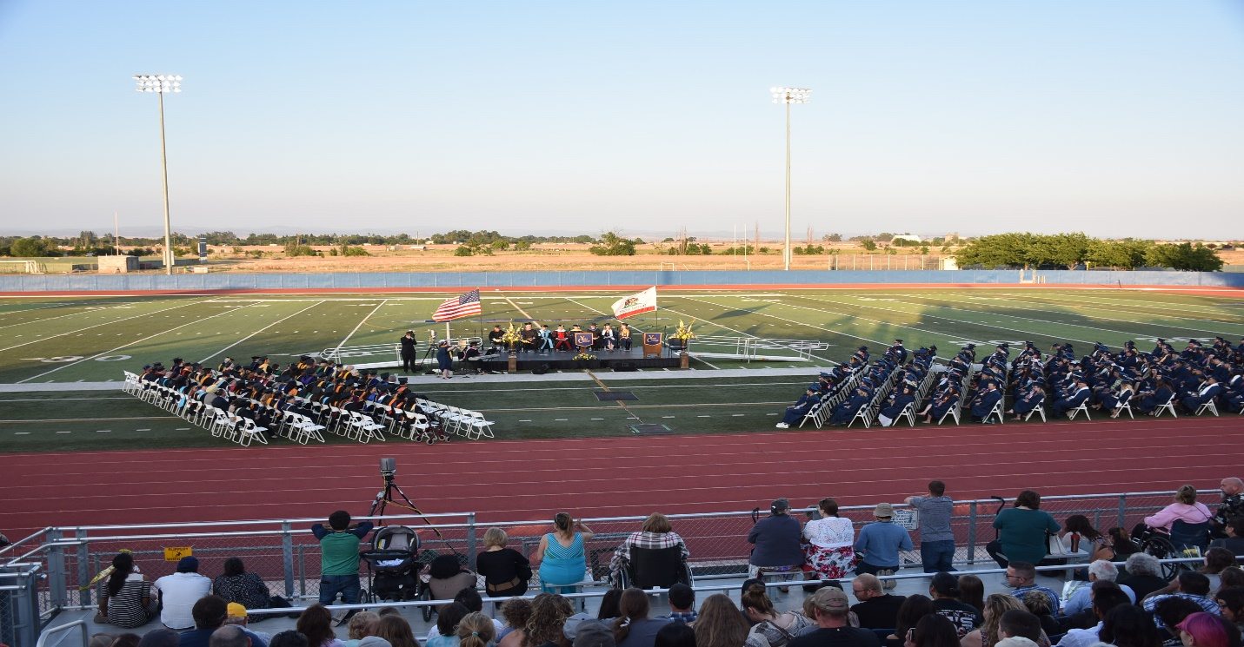
I want to close by reflecting on last spring’s graduation. The Graduation Committee did an amazing job and it was wonderful to see 813 graduates conferred 1,069 degrees. We clearly are doing something right. However, I would like to challenge everyone to think about what we can do to increase student success. Wouldn’t it be great to have 1,000 graduates next year!
Sonja

