

**Yuba College Vice President’s Office Update**

**January 2017**

Welcome back! I hope you have all had a relaxing and fun winter break. As we begin 2017, I am very pleased to have the opportunity to work with more of the dedicated staff and faculty of Yuba College. I am excited about the opportunities and challenges that are before us this Spring. Below are some general college updates and information on some educational trends….

**Removing Barriers to Student Success**

As many of you know, there has been a ***national trend focused on redesigning community colleges to better serve students and improve student outcomes***. The challenge has been figuring out how to make community colleges work for today’s students. This is a pressing societal issue as community colleges in the United States enroll over 10 million students (nearly half of our nation’s undergraduates), yet fewer than 40 percent of students complete their degree or educational goal within six years (Bailey, Jaggars, & Jenkins, 2015).

***Yuba College*** is consistent with the national trends. ***Although 69% of our students state they want to complete a degree and 56% want to transfer,*** they are not achieving their goals……..

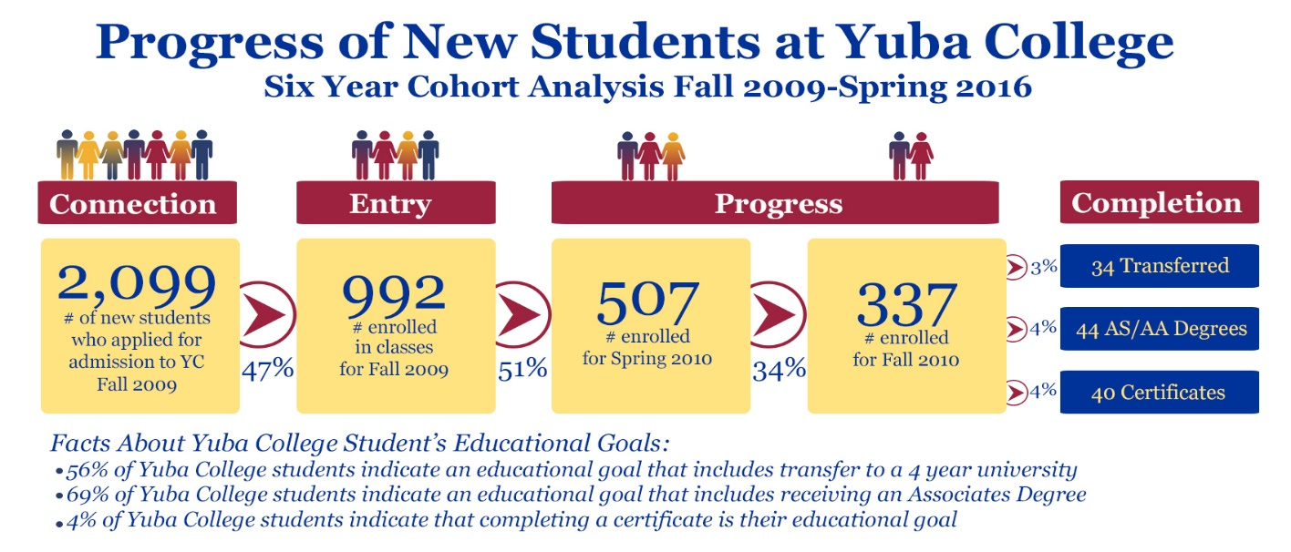

The good news is that there has been a lot of research on how to improve completion and we know that pathways, meta-majors, basic skills acceleration, bridge programs, progress tracking, and other college redesigns have been shown to positively impact student success (see attached article and please contact Zulema if you would like a copy of Redesigning America’s Community Colleges).

I am also very impressed with the **Completion By Design and Guided Pathways** work that has been done to date at Yuba College under the leadership of Georgie O’Keefe, Dan Turner, Korey Champe, Daren Otten, and Delmy Spencer. I encourage you to attend the **Professional Development Day workshop** on this topic to be held on **Wednesday, January 18th at 9AM.**

To further our understanding regarding how students experience Yuba College, we have obtained grant funding to contract with the RP Group to conduct a series of focus groups this spring. The research is designed to provide us insight regarding **students’ experiences at Yuba College at the four stages of the Loss/Momentum Framework: Connection, Entry, Progress, and Completion.**

The Instruction and President’s Offices will be working with Academic Senate and College Council regarding the creation of a taskforce focused on improving student outcomes at Yuba College. The work of this group will align with the Educational Master Plan. **Please consider volunteering to work on this task force……A call for volunteers will go out via Academic Senate and other governance bodies early in the semester.**

**Updated Mission, Vision, and Values Statements**

**Draft Mission**

Yuba College prepares a diverse student population to excel in a rapidly changing, interdependent world. Our quality programs and services empower students to achieve their educational goals by providing transfer preparation, associate and transfer degrees, certificates, career and workforce training, basic skills instruction, and opportunities for lifelong learning. We respond to the diverse educational, cultural, and economic needs of our community by inspiring excellence and developing individual potential in an inclusive environment.

**Draft Vision Statement**

Yuba College will be the regional leader in education and the cultural center of the community.

**We Value:**

Student Success

Excellence in Teaching and Learning

Equity

Inclusion and Diversity

Collegiality and Collaboration

Open, Respectful Dialogue

Data-informed Decision Making

Risk Taking and Innovation

Community Partnerships



College Council will be seeking input from faculty, staff and administrators on the draft mission, vision and values statements developed during the fall 2016 semester. Three compression planning sessions were held and eighty-two faculty and staff developed mission and vision cornerstones which were used to update the mission, vision and values statement below. A survey will be sent out to all Yuba College employees for input and feedback. Please take the time to respond if you have any thoughts or ideas on the draft mission, vision and values statements.

**Dual Enrollment**

A team of faculty, staff and administrators from Yuba College attended a training conducted by the Chancellors Office in December 2016 to learn about College and Career Access Pathways (Assembly Bill 288) and non-AB 288 dual enrollment partnerships. The group will be meeting early this semester to develop a recommendation for Academic Senate regarding how Yuba College could implement a dual enrollment program to support underrepresented groups, facilitate college readiness, and ease the transition to college for students in our service areas.

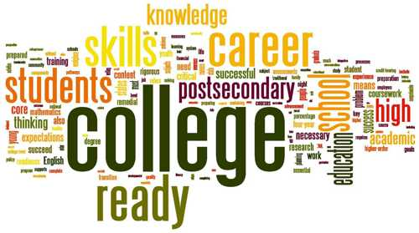

**Accreditation**

Preparation of the Self-Study for the College’s next comprehensive accreditation visit will begin in earnest this spring. ***Brian Jukes is the faculty Accreditation Liaison Officer and CEAC Co-Chair*** and he will be guiding the standard writing teams through the process of writing the Self-Study and gathering evidence**. *I want to recognize and thank everyone who is participating in this very important process:***

**Standard I:** Martin Gutierrez (Standard Lead), Kiara Koenig, Talwinder Chetra, Ruth Tamulonis, Maris Wagener, and Karsten Stemmann

**Standard II:** Angela Willson (Standard Co-Lead), Delmy Spencer (Standard Co-Lead), Meridith Selden, Sherry Spina, Daren Otten, Christopher Noffsinger,Elena Heilman, April Nunez, Julie Miller, Carla Tweed, Kelly Boren, Amandeep Kandola, and Cris Sanchez

**Standard III:** Roy Martin (Standard Lead), Pete Villarreal, Karen Stanis, Kristina Vannucci, and Martin Gutierrez

**Standard IV:** Greg Kemble (Standard Lead), Brian Jukes, Joseph Stottmann, and Anabel Toche

**Other Report Sections:** Brian Jukes, Cassie Leal, Erick Burns, Daren Otten, Karen Stanis, and Kristina Vannucci

If you would like to help with this work, please contact Brian Jukes. No experience is necessary and your participation is needed!

**Educational Master Plan**

College Council is managing the development of the new Educational Master Plan (EMP) for Yuba College. Yuba College’s 2017-2020 Educational Master Plan (EMP) will be a comprehensive document that articulates the College’s vision for the future and will provide a road map for the upcoming three years. Work began on this document last fall and the priorities established in our EMP will serve to guide the institution as it makes decisions about resource allocation, program development, and growth. The plan will contain strategic directions, goals, and a well-defined action plan for how we will reach our vision and measure progress and success along the way. The goals set during the development of the plan will articulate how we will advance student achievement and develop new, innovative practices. Draft documents, timelines and other information can be found at <https://yc-emp.yccd.edu/>.

**Curriculum**

Under the very able leadership of Meridith Selden and Carrie Wasinger, the Curriculum Committee has developed a five year rotational curriculum update schedule, is hosting “Curriculum Triage” workshops, and has instituted procedures to streamline the curriculum approval process. The Committee is working hard to assist faculty with the updating of 143 courses that have been identified as significantly exceeding the review cycle as defined by the State Academic Senate. Progress is being made, but we still have work to do. If you need help with CurricUNET Meta or have any curricular questions, please do not hesitate to contact Meridith, Carrie, myself, your dean, or any Curriculum Committee member. Our goal is to have 100% of the 143 courses updated by the end of the spring 2017 semester. It is critical that we update these classes, as in the future we will not be able to schedule courses that significantly exceed the ACCJC/State Academic Senate update requirements. **Note that there are four Curriculum Triage flex workshops scheduled for January 17th, 18th, 19th and 20th.** We want to support you, so please do not hesitate to contact us if you need any help.

|  |  |  |
| --- | --- | --- |
| **STATUS** | **COURSES** | **%** |
| APPROVED | 21 | 15% |
| DRAFT | 32 | 22% |
| LAUNCHED | 27 | 19% |
| NO PROGRESS | 63 | 44% |
| TOTAL | 143 | 100% |

**Tobacco Free Campus**

As a reminder, effective January 2017 Yuba College transitioned to a smoking and tobacco/nicotine free campus. Frequently Asked Questions (FAQs) developed by the Safety Committee and Administrative Procedure 3570 are attached. Thank you to Karen Stanis and the Safety Committee for their work to make this a smooth transition. We also want to thank Sutter County, Yuba County, and Harmony Health who have donated funding and other resources to this project.

**Enrollment Trends and Other College Facts…**

Enrollments for the fall 2016 and spring 2017 semesters have been flat in comparison to the prior academic year. However, one positive trend we are seeing is sustained growth in the 0-17 student age group. A possibly less positive trend is the increase in the number of part-time students and a decline in students taking twelve or more units each semester. ***The Research Office is finalizing a Fact Book that is full of interesting data and will be available in early February.***





**YC Employee Mailroom Changes---Marysville Campus**

With the district move, there was a definite need to update the Yuba College mailroom. Work has begun on updating the adjunct mailboxes and merging adjunct boxes into the permanent employee mailroom. The rationale for the change was to better communicate with all employees, to save duplicating expense on promotional items, and--most importantly--to bring all employees together in one room!

**Classroom and Student Services Visits**

Robert Mathews suggested I visit some classrooms this spring to see the outstanding work that is being performed at the Marysville, Sutter, and Beale Campuses. As a long-time instructor, I very much miss being in the classroom and thought this was a great idea. If there is a convenient time for me to drop by to see you and your students in action…maybe your favorite lecture, a lab demonstration, counseling session, or student presentations; please let me know.

**Welcome** 

Please join me in welcoming our new Yuba College employees…

**Faculty**

Melissa Ha, Associate Professor, Biology

Priscilla Hernandez-Neil, CalWORKs Counselor

**Classified Staff**

Jason Goerz, Science Lab Technician

Amber Kuykendall, Veterinary Technology Specialist

Paul Mickelson, Instructional Associate, Math

Jesus-Adriana Valdez, Child Development Assistant

As the semester begins, I want to thank you for your dedication to our students and for all the amazing work you do for the College. The work performed at Yuba College is truly important and it all starts with you….the faculty member who engages and inspires, the classified staff member who supports and encourages, and the administrator who works to develop and maintain high quality programs and services.

Best wishes for a smooth start to the spring semester and if I can help you in any way, give me a call at (530) 741-6766

**Sonja**